Art Assignment

Student’s Name
Institutional Affiliation
Course Name and Number
Instructor’s Name
Assignment Due Date

a)
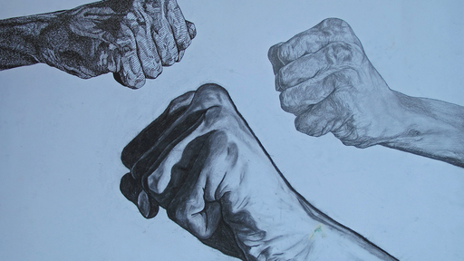
b) Tension in the piece of art, is created through the application of different techniques in drawing, since one arm uses shadows, another arm is in moderate light and the other arm in the top applying three-dimensional techniques with a bland of darker colors. The piece of art can be interpreted to be objective on peace and unity as the right arm is raised in solidarity. Tension is thus created whereby the different techniques of drawing each arm are an exhibition of differences, thus brought together by solidarity (Para 4). Since tension creates emotional sense such as hate or sin, the tension created in the piece is solidarity and differences. Contrasts of color, shadow and tones are the aids of creating tension in the artwork.
c) An exhibition of two tension types is experienced in the artwork. One is experienced in the drawing, and the other experienced in the message being portrayed. The arm below uses shadows in higher amounts, while the arm in the middle uses high contrast, and the upper arm uses small shapes. A range of experiences arise from the different perspectives, from unevenness, to race, or differences that the individuals bear. Opposing styles are thereby used to create colors and forms that explicitly (Para 6). Contrast therefore is used to set the idea of differences, in a unifying background, that is light blue, visually creating a cool aura.
Since the artwork exploit artistic techniques to bring out the differences, often differences being a conflicting term, the message in the artwork thereby exhibits another aspect. A dark background is an attribution to cool, and the contrast of differences has a unifying factor. Since tension is about both sides of art, the good and bad, echoing opposites is an essence in artwork and is successfully created. Tension thus is for appreciation of different things in life, as art is also a language.
As tension may portray the artistic language, tension is solved in the artwork through inclusion of a message, in the drawing, which may also be interpreted as a sign of solidarity, when the individuals raise their right hands (Para 7). Since the individuals are difference, there is emphasis of peace in the background color selection, and a united aura, tension is harmonized into ‘solidarity despite differences.’

References
Richard J, (2019). Experiencing the humanities, Chapter Nine.

